

Programación Orientada a Objetos

inspectors (group #3)::

Chiliquinga Lema, Bryan David

Coba Flores, Victor Steve

Contreras Farinango, Ian Marcelo

Criollo Gualotuña, Kevin Orlando

Cuaspa Cuaspud, Eliana Aidee

**group #4 ratings.**

GitHub /50

Requirements 9/10 missing nouns in the problem, there is not clear goal,

Use Case D 9 /10 no pdf file, they must not be linked together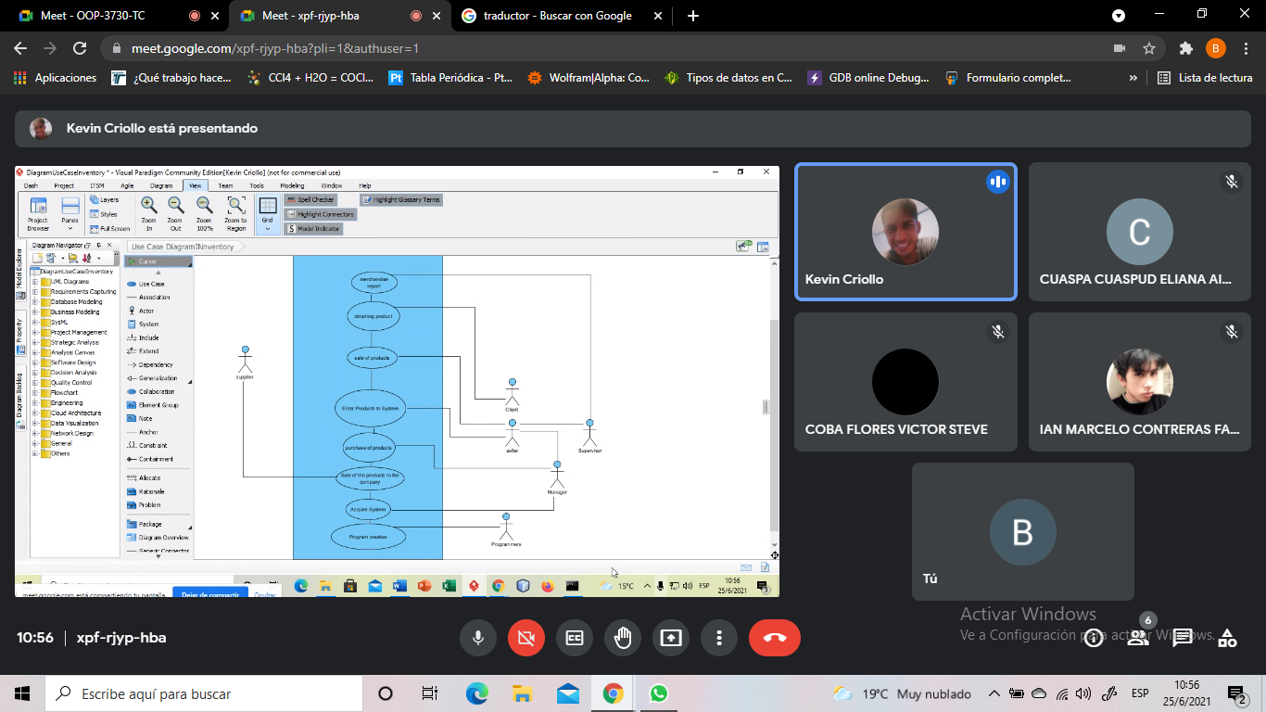

Class D 8.5/10 There is no specification in the name of the diagram, lank of multiplicity, it is not packaged

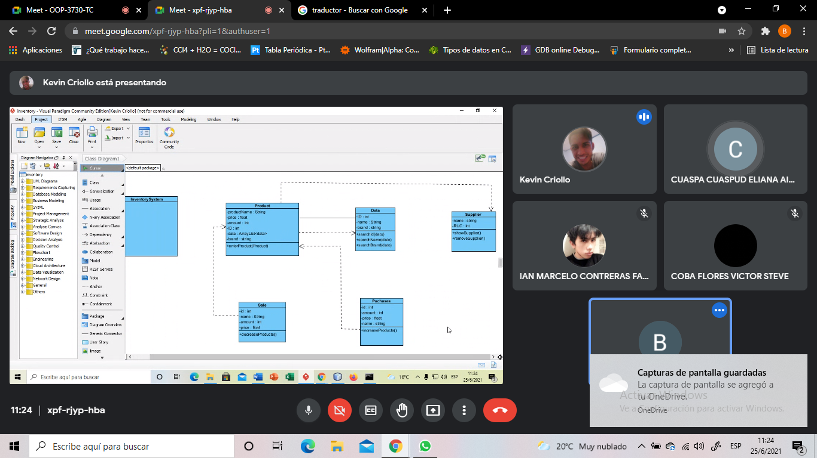

Code 8.5 /10 Unnecessary commando lines, some classes don't exist in the class diagram

Recommendation:

The class diagram has no relation to the program

Executable 9.5 /10 Program does not compile correctly

Recommendation:

The execution of the project must be clear to the user

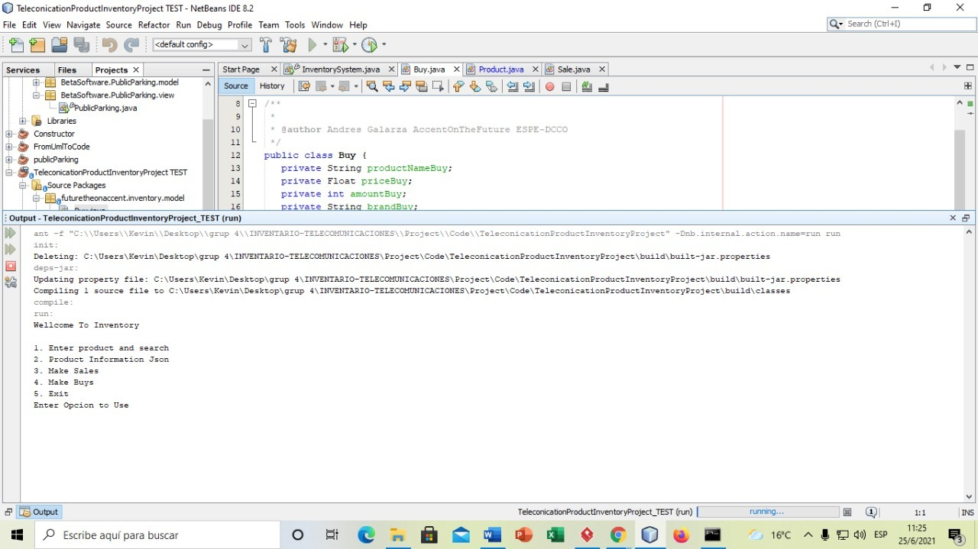

We rating the group 4